**Temperature profile** (against Height)

The following temperature profile was obtained :

The different lines are for different *number of grids*

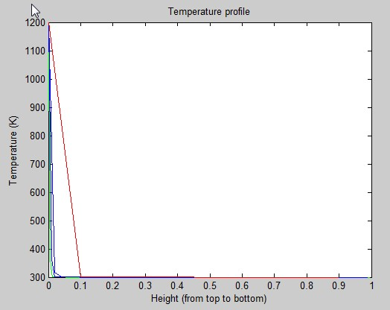

Color Coding: (*No. Of grids*)

Red : 10

Blue : 50 ( & 100 )

Green : 300

This result was obtained after **100 seconds.**

Unexpected result since the lower layers will not remain at low temperatures.

*Clearly, the error is not due to insufficient number of grids since it is greater for higher number grids.*

The following method was used. (method of lines)

We use overall heat balance equation for the first grid.

$$mC*\left(\frac{dT}{dt}\right)= K*\left(\frac{d^{2}T}{dx^{2}}\right)+h\left(T-To\right)+ e(Ts^{4}- T^{4})$$

For the other grids :

$$mC*\left(\frac{dT}{dt}\right)= K*\left(\frac{d^{2}T}{dx^{2}}\right)+h\left(T-To\right)$$

The odes were solved using **ode15s**

The spatial coordinate was discretized using 2nd order finite difference equations.

For the above results the parameter values were as follows (all S I units)

Thermal Conductivity = 0.1 J m-1 s-1 K-1

Specific Heat = 1500 J kg-1 K-1

Density = 800 kg m-3

Temperature Surface = 1200K

Air Temperature = 300 K

Length, Width , Height = 1m

Overall Heat transfer coefficient = 32 J s-1 K-1 (around this value)